

III SEMESTER MCA
IN-SEMESTER EXAMINATION – 2 (OCT’22)
SUBJECT: Machine Learning [MCA 5152]

Date: 18/10/2022 Max. Marks: 15
Time of Exam: 08:15AM –09:15 AM

Instructions to Candidates:
- Answer ALL the questions.
- For any calculations, all important steps need to be properly written.
- Use of Calculator is allowed. Use of Mobile is NOT allowed
- Missing data may be suitably assumed.

1A. | Differentiate between feature selection and feature extraction in dimensionality reduction. | 1
 | The key difference between feature selection and extraction is that feature selection keeps a subset of the original features while feature extraction creates brand new ones. Feature Extraction transforms an arbitrary data, such as text or images, into numerical features that is understood by machine learning algorithms. Feature Selection on the other hand is a machine learning technique applied on these (numerical) features.
1B. | What is memory-less property of Markov Models? Write an equivalent mathematical notation to denote that. | 1
1C. | Differentiate between PCA and LDA dimensionality reduction techniques. | 1
 | LDA focuses on finding a feature subspace that maximizes the separability between the groups. While Principal component analysis is an unsupervised Dimensionality reduction technique, it ignores the class label. PCA focuses on capturing the direction of maximum variation in the data set. Specifically, PCA is often used to compress information i.e. dimensionality reduction.
1D. | Define any TWO (2) feature selection techniques. | 1
Define Any TWO.
Missing Value Ratio: If dataset has too many missing values, then drop those variables. These variable do not carry much useful information.
Low Variance Filter: Variance is measure of variability/dispersion. This method acts similar like missing value ratio technique. Variables with little changes in data have less information. Low variance features will not significantly affect target variable.
1E. | Write the Baye’s theorem. Also write the mathematical representation along with explanation of variables. | 1
2A. | For the state transition table given below (for sunny/rainy/foggy days), draw the state transition diagram with relevant labels. Assume that today’s weather is Sunny. Show the initialization vector and the input data vector given the initialization state.  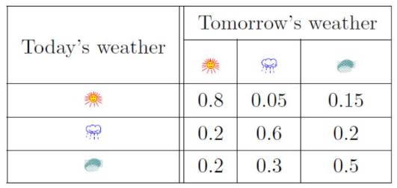 | 2
2B. | Apply Naive Baye’s classification on Table 2.1 to decide whether a local yellow SUV would be at risk of being stolen or not?  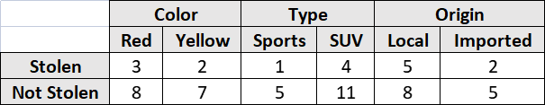  Table 2.1: Car Database | 2
 | 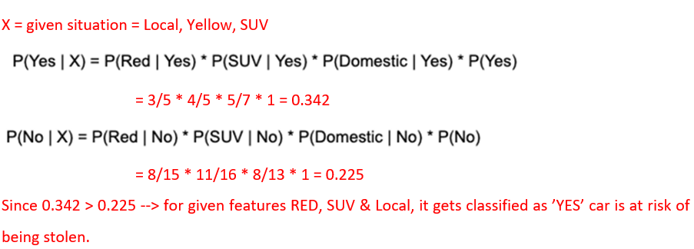
3A. | Apply PCA to find the PC1 for the given covariance matrix in Table 3.1 (a) for the dataset in Table 3.1 (b).  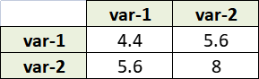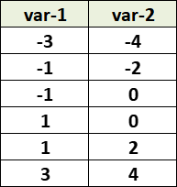  Table 3.1: (a) Covariance Matrix & (b) dataset | 3
 | 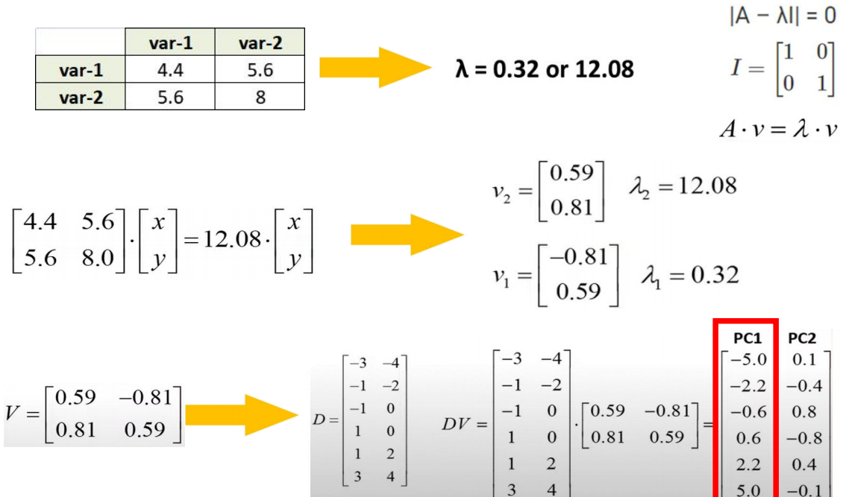
3B. | Write the sequential steps along with the necessary formulae (if any) to preform PCA.  Compute the Covariance matrix for the given data in Table 3.2.  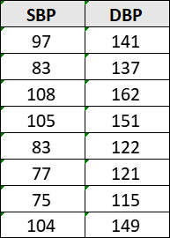  Table 3.2: Patient Database | 3


    

